Practical #7
Practical Title:
To understand automated testing concepts and Selenium architecture for web applications
Theory:
1. What is Automated Testing?
Automated testing is a software testing technique where test cases are executed using tools and scripts instead of manual effort. It helps in verifying that the application works correctly by running tests quickly and repeatedly
2. What is Selenium?
Selenium is an open-source tool used for automating web browsers. It is widely used for testing web applications across different browsers and platforms.
3. Selenium Components:
Selenium IDE:
- A browser extension used for recording and playback of test cases
- Easy for beginners
- Does not require programming knowledge

Selenium WebDriver:
- A programming interface for writing test scripts
- Supports languages like Java, Python, C#, etc.
- Directly interacts with the browser

Selenium Grid:
- Used for parallel testing
- Runs tests on multiple machines and browsers simultaneously
- Saves time and increases efficiency
4. Selenium Architecture:
Selenium architecture consists of the following flow:
Test Script → WebDriver API → Browser Driver → Browser → Application

Explanation:
- Test Script:
Written by the tester in a programming language (Java, Python, etc.)
- WebDriver API:
Acts as an interface between test script and browser driver
- Browser Driver:
Specific driver (like ChromeDriver) that communicates with the browser
- Browser:
Executes the commands and interacts with the web application
- Application Under Test:
The website or web app being tested

Procedure:
Step 1: Install Selenium and required dependencies
Step 2: Setup WebDriver
Step 3: Write a simple test script
Step 4: Perform actions (click, input, etc.)
Step 5: Execute the test script
Output Screenshots:
(Paste screenshots of code and execution)

Activity / Task:
Task 1:
Write a Selenium script to open a website and perform basic actions.
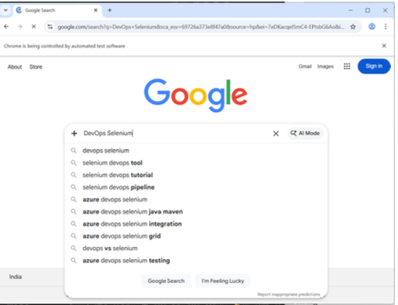
Code:
from selenium import webdriver
from selenium.webdriver.common.by import By
from selenium.webdriver.common.keys import Keys
import time
driver = webdriver.Chrome()
driver.get("https://www.google.com")
driver.maximize_window()
search_box = driver.find_element(By.NAME, "q")
search_box.send_keys("Selenium Testing")
search_box.send_keys(Keys.RETURN)
time.sleep(3)
driver.quit()
Task 3:
List advantages of automated testing over manual testing.
Advantages of automated testing over manual testing:
- Faster execution of test cases
- Reusable test scripts
- More accurate (reduces human errors)
- Supports repeated testing
- Suitable for large-scale applications
Advantages:
- Saves time and effort
- Increases test coverage
- Improves accuracy
- Enables continuous testing (CI/CD)
- Reusable test scripts

Challenges:
- Initial setup cost is high
- Requires programming knowledge
- Maintenance of test scripts

